

Project Report

A brief description of my Game Website project



December 11, 2020

Saad Ahmad

**Features of the game:**

User character is marching forward while an enemy character is present at the other end of the canvas sneezing and sending coronaviruses towards the user character. The user can press spacebar to jump over the incoming coronaviruses and avoid coming in contact with it. The number of seconds spent playing the game before the user character touches the coronavirus object is the total score. There are masks along the way which the user can take to increase its score count.

**Registration:**

When the user clicks ‘Play’ on the home page, they will be directed to the registration page. The user needs to fill in the following four fields: username, email address, phone number, and password. If any of the fields are left empty or the details entered are invalid, then the user will be prompted by an appropriate error message; for example, a valid email address must contain ‘@’ character, password should be at least eight characters long, and the phone number should be of correct UK format. Along with these details, the user’s logged in status and top score will also be store. The user’s logged in status will be initialized as true, whereas the top score of the user will be initialized with a value of zero. All these user details will be stored in local storage in JSON format. After filling in all the required fields with valid details and clicking ‘submit’, the user will be ready to log in and play the game.

**Login:**

Registered users can enter their email address and password to log in. If the email address and password combination does not match that of any registered user, then the user will be prompted by an error message saying, “incorrect Password/Email address”. This error message makes it harder for hackers to guess the account details. If the log in details are correct, then the user will be prompted by a ‘registration successful’ message and will be directed to the game page. Moreover, the user can always click ‘logout’ on the bottom right-hand side of the webpage to log out and return to the home page. Upon clicking ‘logout’, the user’s logged in status will change from true to false and will be stored in local storage in JSON format along with user’s other details.

**Rankings:**

The user can play the game as many times as they want, but only their highest score will be recorded and displayed on the leaderboard alongside their username. After the game is over for the user, their top score will be updated and stored in JSON format in local storage along with other details of the user. The leaderboard will have a list of all registered users along with their best scores.

**Screenshots:**

Home page

Registration page

Leaderboard

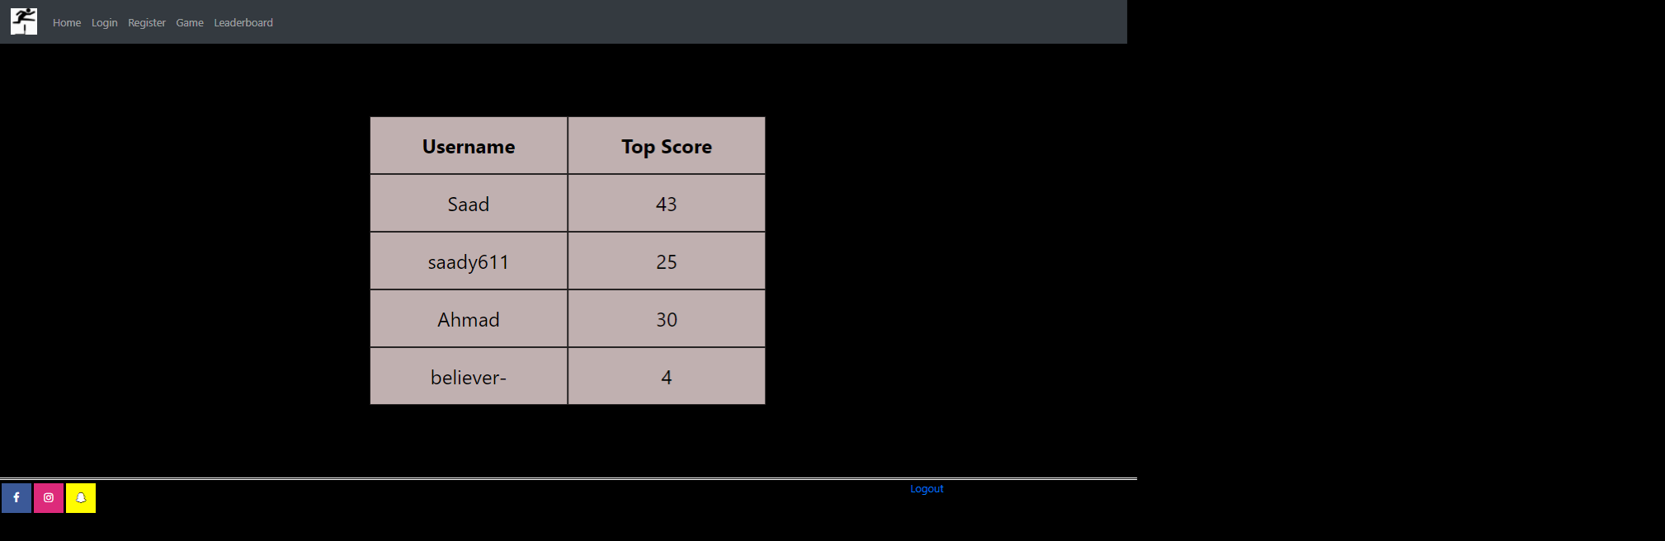

Game Page

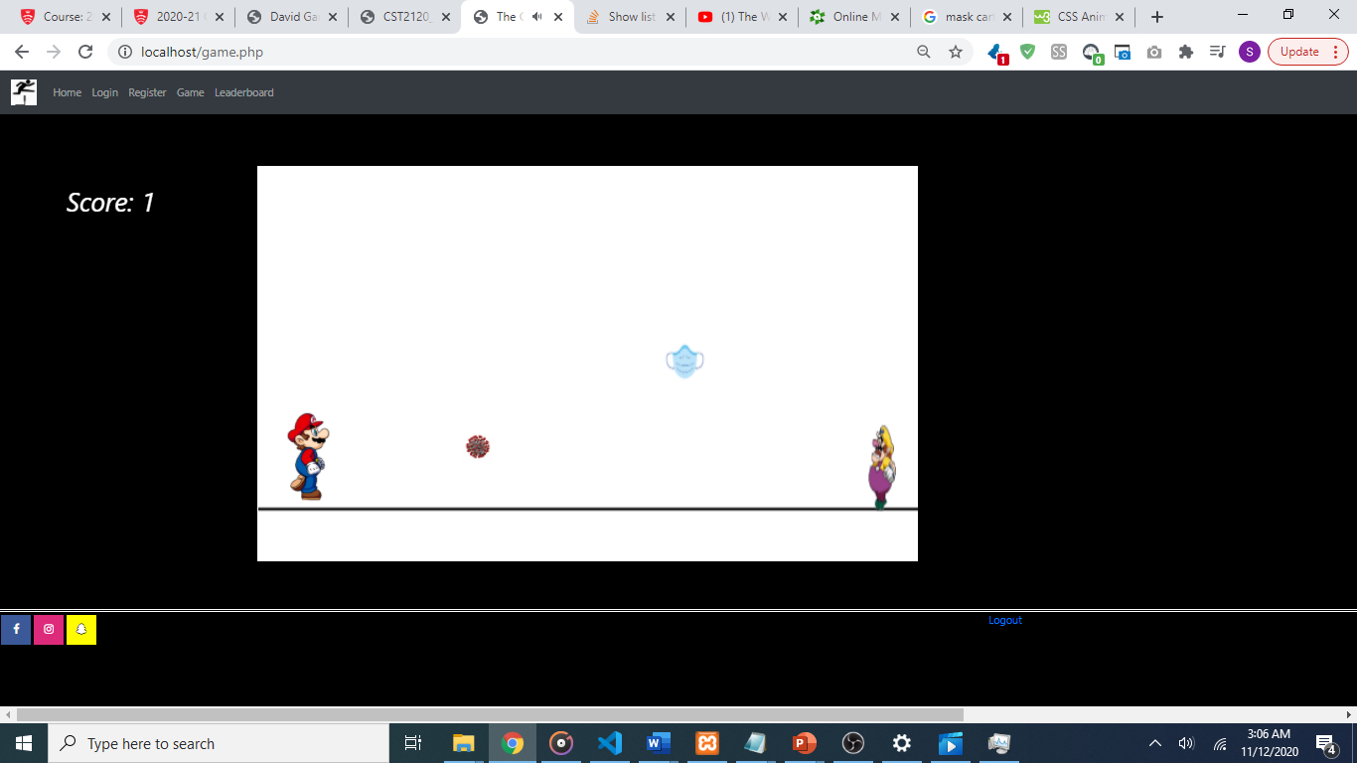

The background music in the game is obtained from the following source: [*https://www.youtube.com/watch?v=XajaJYraODs*](https://www.youtube.com/watch?v=XajaJYraODs)

**Issues with development**

Since I used CSS animations for my characters and objects of the game, there were occasional glitches in the game. The game did not run as smoothly as I would want it to when I was recording the video demonstration as OBS studio was running in the background on my low-end pc.